Arrays vs LinkedList Why Linked List?
Thu, 23 Apr 26
Arrays Fundamentals
- Sequential memory storage with indexed access starting from 0
- Each element occupies contiguous memory blocks
- Computer memory consists of bytes with unique addresses
- Programming languages track variables and their memory locations
Array Limitations
- Fixed data type requirement
  - Integer arrays only store integers
  - String arrays only store characters
  - Object arrays must contain same object type
- Fixed size constraint
  - Size determined at creation time
  - Cannot be modified after declaration
  - Resizing requires creating new array
- Sequential memory dependency
  - Requires contiguous memory blocks
  - Cannot utilize scattered memory efficiently
  - The memory addresses will also be in order like Memory address example =4112, 4113, 4114, 4115
Linked List Structure
- Collection of nodes containing data + link to next node ( data + link(address of next data))
- Each node is stored at a unique memory address
- Links store memory addresses of next nodes (not physical arrows)
- Non-contiguous memory locations
- Last node link points to null
Memory Utilization Comparison
- Arrays: Sequential memory allocation
  - Predictable but inflexible
  - Potential memory waste or shortage
- Linked Lists: Dynamic memory allocation
  - Nodes created as needed
  - Efficient memory utilization
  - Links enable navigation between non-sequential locations
Linked List Advantages
- Dynamic sizing during program execution
  - Add elements by creating new nodes
  - Remove elements by changing links
  - No predetermined size limitations
- Flexible memory management
  - Allocate memory only when needed
  - Better adaptation to changing requirements
- More suitable for unknown data size scenarios
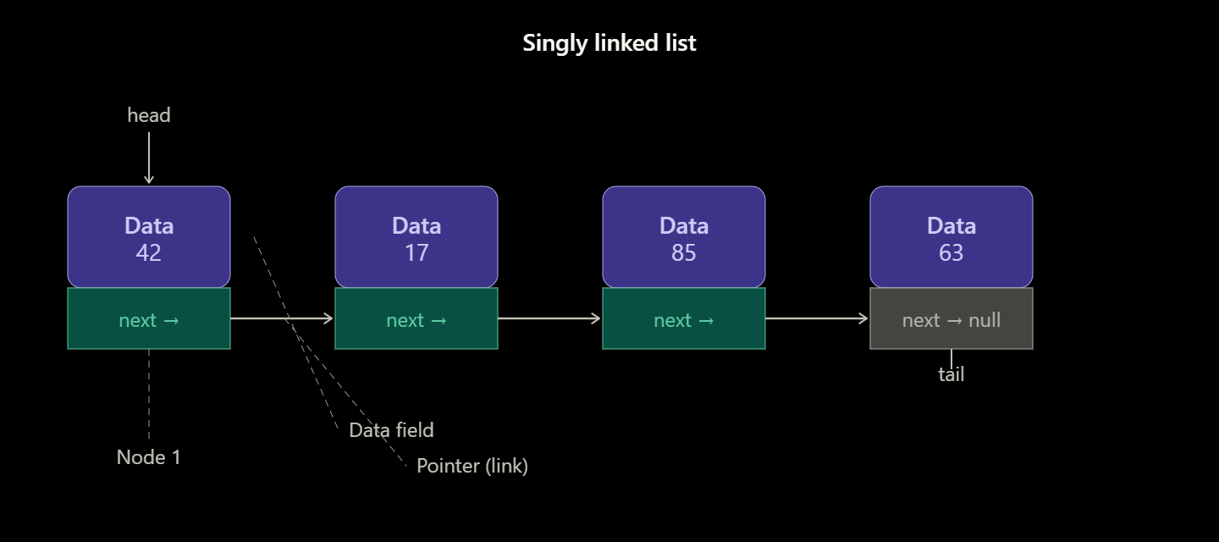
Here's the linked list diagram! Here's what it shows:
- Node — each block is a node, split into two sections: a data field (top, in purple) storing the actual value, and a pointer field (bottom, in teal) holding the address of the next node.
- Links (arrows) — each pointer connects one node to the next, forming the chain.
- Head — a special pointer marking the start of the list. This is how you access the list.
- Tail — the last node, whose next pointer is null, signalling the end of the list.
To copy it into a document, just right-click the diagram → Copy image, then paste it directly into Word, Google Docs, or any editor that accepts images.
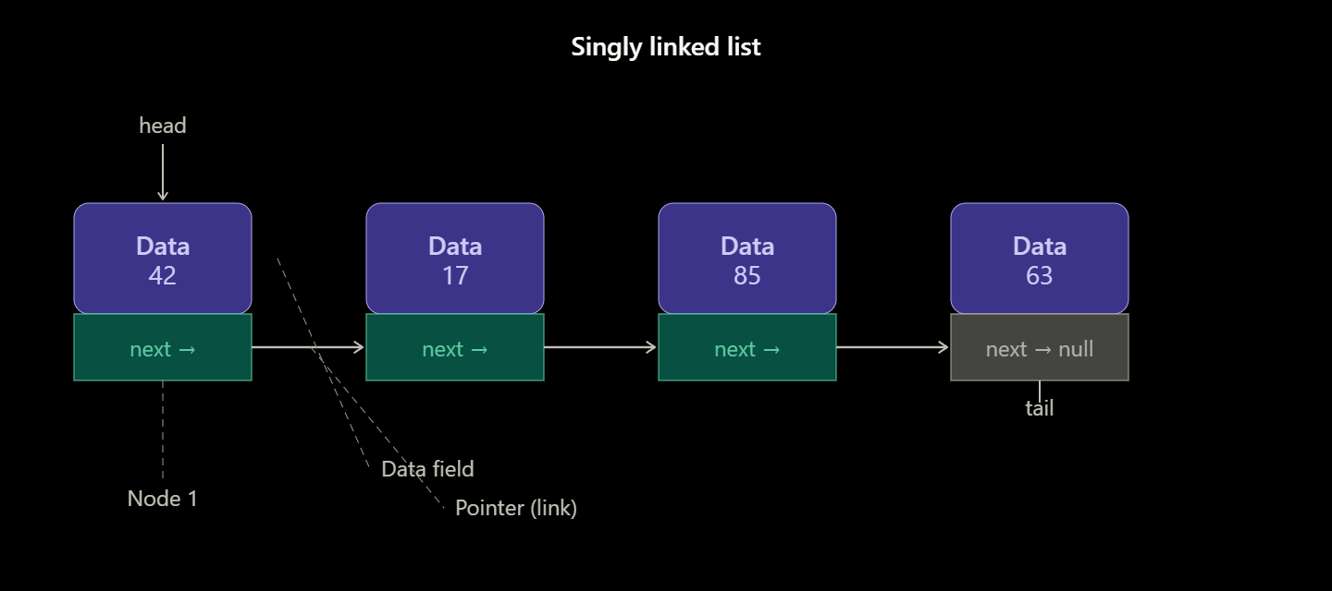
This updated diagram shows the key insight about linked lists — the nodes don't need to sit next to each other in memory at all. Here's what to notice:
- Each node lives at a random memory address (like 0x41T2344, 0xB8F0012, etc.) — they're scattered all over RAM, not in a neat row.
- The teal pointer field inside each node stores the address of where the next node lives. That's how the chain is formed — not by physical proximity, but by these address references.
- The arrows represent the logical sequence the pointers create, jumping from one address to another in the correct order: 42 → 17 → 85 → 63.
- The last node's pointer is NULL, signalling the end of the list.
This is what makes linked lists fundamentally different from arrays — an array needs a contiguous block of memory, while a linked list can stitch together nodes from anywhere in memory using pointers.

